Southern Tier Chapter of
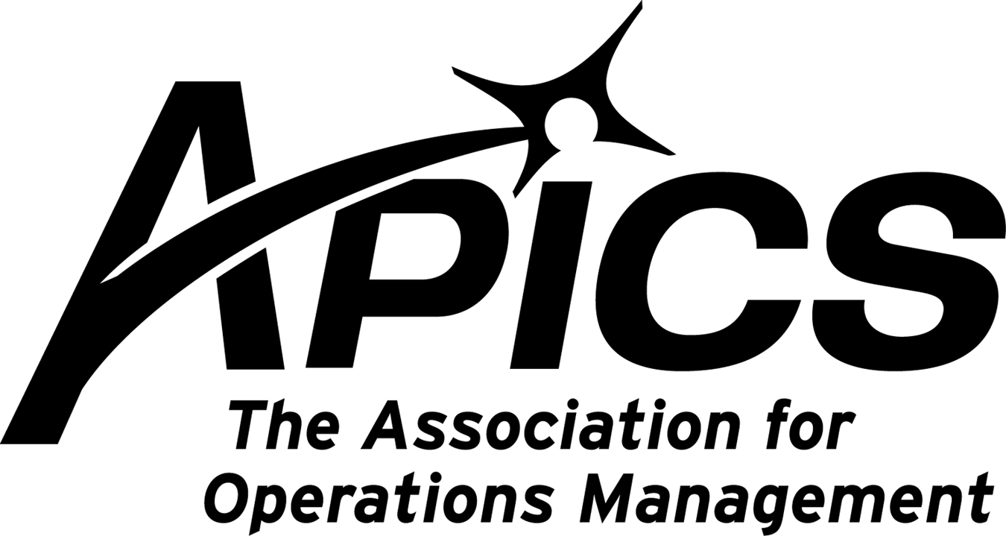
www.stapics.org

“Advancing productivity and innovation and competitive success.”

NO PDM DINNER MEETING

APICS NorthEast District Student Competition -Resources
April 16, 2011 at Quinnipiac University, Hamden, CT

Competition Summary
A team comprised of four students will be presented with an operations management/ supply-chain case:
• Case is approximately 15-20 pages

• Students have four hours to analyze the case and create a PowerPoint presentation with their recommendations to Senior Management

• Students have fifteen minutes to present their solution to a panel of judges. (Judges are respected
professionals and senior corporate managers.)

• We are recruiting University teams from NY, NJ and New England

• Participation is limited to 24 teams
– 12 Graduate and
- 12 Undergraduate teams

Student Prizes
• 1st Place Team: $1,200

• 2nd Place Team: $800

• 3rd Place Team : $500

• 4th and 5th Place teams get APICS student memberships for one year.

*All winning teams may receive a one year APICS student membership.

More information will be posted at http://www.bostonapics.org/students.cfm

Educational Opportunities!!!

Seminar 1 Educational Conference / Expo and Lean Six Sigma Certificate Workshop
Conference: April 25 - 26, 2011
Lean Workshop: April 27 - 28, 2011

Holiday Inn Hotel & Suites
265 Lakeside Avenue
Marlborough, MA 01752
P 508-481-3000 F 508-357-8841

Please click here for more information and registration

ISM's 96th Annual International Supply Management Conference & Educational Exhibit
May 15-18


Click here to register.

A Message from APICS Northeast District

The staff of the Northeast District wishes to extend to you a HUGE, heartfelt THANK YOU for attending our February District Meeting. This meeting was one of our best ever from a quality of presentations and attendee participation point of view! We are adding the presentations as quickly as we can to the website www.apicsnortheast.org so you can refer to them and show them to your colleagues that couldn't attend. Check out the site -- there might even be a picture of YOU up there!

Special thanks to our presenters:
Dave Rivers
Tawana Collins
Tom Foley
Reed DuBow
Jim Timmons
Jeff Ball
Art Harvey
Joe Shedlawski

Extra special thanks to the Albany Chapter for its superb Hospitality Arrangement [sponsored by a number of contributing chapters]. Don't hesitate to contact us through the "Ask Away" feature on our website!

Remember to set aside May 13th and 14th for our next meeting in the northern New Jersey area!

Jennifer Kevlin, CPIM, CSCP
APICS Northeast District Manager, 2011-12

We’re on !!!

Come and visit, poke around, or comment on us! Our name there is “Southern Tier Apics”. It’s just another way
for us to keep in touch with our membership.

For the latest in chapter happenings check out WWW.STAPICS.ORG

Your 2010-2011 Board of Directors

President / VP Education Dave Gardner dgardner@akraturn.com
VP Membership / Website Lee Schechter lschechter@stny.rr.com
Executive VP / Director of Finance Steve Whited steve.whited@mwv.com
Director of Education Don Sheldon dsheldon@stny.rr.com
Publicity / Marketing / Programming Michael LoSapio Michael.losapio@synergyresources.net
Marketing Director Kelly Norieka Kelly.norieka@lmco.com
Secretary Deb Unkel deb.unkel@raymondcorp.com

Southern Tier APICS
PO Box 1107
Binghamton NY 13902-1107

